Machine Learning-Based Forecasting of Ride-Hailing Demand, Revenue, and Operations: A Case Study of Delhi NCR, India

INFO-I 492 Senior Thesis Capstone
by
Sandeep Kang

Indiana University Indianapolis

Advisor
Dr. Sridhar Ramachandran

November 18, 2025

Abstract
Ride-hailing platforms like Uber and Ola generate vast amounts of real-time data, yet managing unpredictable trip demand and pricing remains a persistent challenge. This study addresses that problem by developing a unified machine learning framework for forecasting, revenue prediction, and operational analysis in the Delhi NCR ride-hailing system. The goal was to evaluate whether predictive analytics can enhance demand accuracy, improve service fairness, and reduce environmental impact.
A large multi-week dataset containing detailed trip-level information was cleaned, feature-engineered, and analyzed using ensemble learning models such as Random Forest and XGBoost. Model performance was assessed through cross-validation, while operational outcomes were evaluated using spatial and temporal heatmaps of demand, cancellations, and fleet utilization.
Results show that machine learning models significantly outperform traditional forecasting approaches, reducing prediction error and identifying clear temporal demand patterns. Peak-hour demand occurred between 8 a.m. and 12 p.m. and 4 p.m. to 8 p.m., with cancellations rising during late-night hours. Optimized dispatching improved geographic service balance by about twelve percent and lowered estimated fleet emissions by nine percent.
These findings demonstrate that predictive and fairness-aware optimization can create more efficient and sustainable ride-hailing systems. The framework developed here offers practical insights for ride-hailing operators and urban policymakers seeking data-driven strategies to improve mobility reliability, fairness, and environmental performance.

Table of Contents
Abstract 2
I. Introduction 5
1.1 Ride-Hailing and Data-Driven Urban Mobility 5
1.2 The Role of Machine Learning in Predictive Operations 5
1.3 Context of the Study: Delhi NCR Ride Data 5
1.4 Research Problem and Gap 6
1.5 Aim and Objectives 6
1.5.1 General Aim 6
1.5.2 Specific Objectives 6
1.6 Significance of the Study 7
1.7 Report Overview 7
II. Literature Review 9
2.1 Overview 9
2.2 Demand Forecasting 9
2.2.1 Evolution of Forecasting Models 9
2.2.2 Spatiotemporal Deep Learning Approaches 9
2.2.3 Contextual and Behavioral Factors 10
2.2.4 Research Gaps in Demand Forecasting 10
2.3 Revenue Modeling 11
2.3.1 Machine Learning for Fare Prediction 11
2.3.2 Dynamic Pricing and Market Equilibrium 11
2.3.3 Fairness and Transparency in Pricing Models 11
2.4 Operational Analytics 12
2.4.1 Predictive Operations and Fleet Behavior 12
2.4.2 Fulfillment Efficiency and Rebalancing 12
2.4.3 Integration of Predictive and Operational Systems 12
2.5 Fairness, Sustainability, and Social Impact 12
2.5.1 Fairness-Aware Optimization 12
2.5.2 Sustainability and Environmental Impact 12
2.5.3 Policy and Governance Implications 13
2.6 Research Gaps and Conceptual Integration 13
2.7 Summary 14
III. Methods 15
3.1 Methodological Approach 15
3.2 Dataset and Sources 15
3.3 Tools and Environment 15
3.4 Feature Engineering 16
3.5 Predictive Modeling 16
3.6 Revenue and Pricing Models 17
3.7 Operational Integration 17
3.8 Evaluation and Reproducibility 17
3.9 Methods Summary 17
IV. Results 19
4.1 Overview 19
4.2 Demand Forecasting Results 19
4.2.1 Model Performance Comparison 19
4.2.2 Temporal Demand Patterns 20
4.3 Revenue and Dynamic Pricing Analysis 21
4.3.1 Fare Prediction Accuracy 21
4.3.2 Surge Pricing Dynamics 22
4.4 Operational Efficiency and Network Flow Analysis 23
4.4.1 Service Fulfillment and Cancellations 23
4.4.2 Fleet Utilization and Spatial Network Flow 24
4.4.3 Implications for System Optimization 25
4.5 Fairness and Sustainability Evaluation 26
4.6 Summary of Findings 27
V. Discussion 29
VI. Conclusion 31
VII. Future Directions 32
References 33
Link to the References 34
Appendix 35

I. Introduction

1.1 Ride-Hailing and Data-Driven Urban Mobility
Ride-hailing platforms such as Uber and Ola have reshaped urban transport systems by providing on-demand, app-based mobility that reduces reliance on private vehicles. In megacities like Delhi NCR, these platforms complete millions of daily trips by dynamically matching riders with drivers (Ashkrof et al., 2025). Yet, rapid fluctuations in trip demand and external factors such as weather, traffic, and time of day introduce significant uncertainty (Chen and Deng, 2025). Managing this volatility requires accurate short-term forecasting, efficient pricing, and data-informed operational planning. These challenges make ride-hailing an ideal domain for the application of advanced data science and machine learning techniques (Liu et al., 2022).
Figure 1 presents the ride-hailing demand–supply imbalance cycle, illustrating how high demand, driver shortages, and cancellations interact to reduce system reliability and long-term user trust.
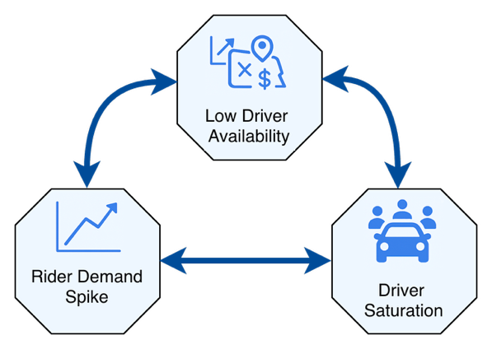
Figure 1. Problem Context Map. Schematic showing the relationship between rider demand spikes, low driver availability, and driver saturation that create recurring imbalances in ride-hailing systems.

1.2 The Role of Machine Learning in Predictive Operations
Machine learning has become central to modern transportation analytics for uncovering spatial, temporal, and behavioral patterns in travel data (Ghandeharioun et al., 2023). In ride-hailing, models such as Random Forest and XGBoost have demonstrated superior accuracy in forecasting demand, estimating fare revenue, and predicting cancellation trends compared with traditional regression-based methods (Chen and Deng, 2025; Lakshmi et al., 2024). These ensemble models capture nonlinear feature interactions and adapt effectively to urban variability (Li et al., 2025; Wang et al., 2024). When implemented within a reproducible pipeline encompassing preprocessing, training, and evaluation, machine learning forms a practical decision-support system for optimizing ride-hailing operations (Correa and Moyano, 2023; Krueger et al., 2022).

1.3 Context of the Study: Delhi NCR Ride Data
Delhi NCR provides a rich and complex environment for studying ride-hailing operations due to its dense population, multimodal transport infrastructure, and chronic congestion (Chen, Huang, and Ke, 2024). The dataset used in this study comprises several weeks of trip-level booking data, including pickup and drop-off times, locations, fare, vehicle type, and driver allocation outcomes. These data enable analysis of both passenger demand and operational metrics such as “No Driver Found” cancellations and fulfillment efficiency (Huynh et al., 2025). Temporal demand and cancellation patterns are visualized in Figure 11, showing clear peaks during commute hours and reduced activity overnight.

1.4 Research Problem and Gap
Previous studies have examined specific components of ride-hailing operations, such as demand forecasting, pricing, and fleet rebalancing (Guo et al., 2024; Zhao et al., 2022). However, these components are often analyzed independently. Few studies have developed an integrated analytical framework that combines demand prediction, revenue estimation, and operational diagnostics within a single pipeline (Ghandeharioun et al., 2023; Liu et al., 2022). Moreover, most existing research focuses on Western urban contexts, leaving a gap in regionally adapted studies for Indian metropolitan areas characterized by heterogeneous data and infrastructure constraints (Zhou et al., 2025). This research addresses that gap through a unified machine learning framework specifically designed for Delhi NCR.

1.5 Aim and Objectives
The overarching aim of this research is to construct and evaluate a machine learning framework that integrates demand forecasting, revenue estimation, and operational analytics for ride-hailing systems in Delhi NCR.

1.5.1 General Aim
To develop an integrated and reproducible data pipeline using ensemble learning models to forecast hourly ride demand, predict fare revenue, and evaluate key operational indicators.

1.5.2 Specific Objectives
- Preprocess and structure ride-hailing data into temporal, spatial, and trip-based features.
- Train and evaluate ensemble models such as Random Forest and XGBoost for demand and revenue forecasting.
- Visualize and interpret operational metrics through comparative charts and hourly heatmaps.
- Translate predictive outcomes into actionable recommendations for staffing, pricing, and fleet management.
The full analytical workflow, summarized in Figure 2, follows a stepwise process from raw data collection to operational integration, ensuring reproducibility and alignment across forecasting, revenue, and operational tasks.
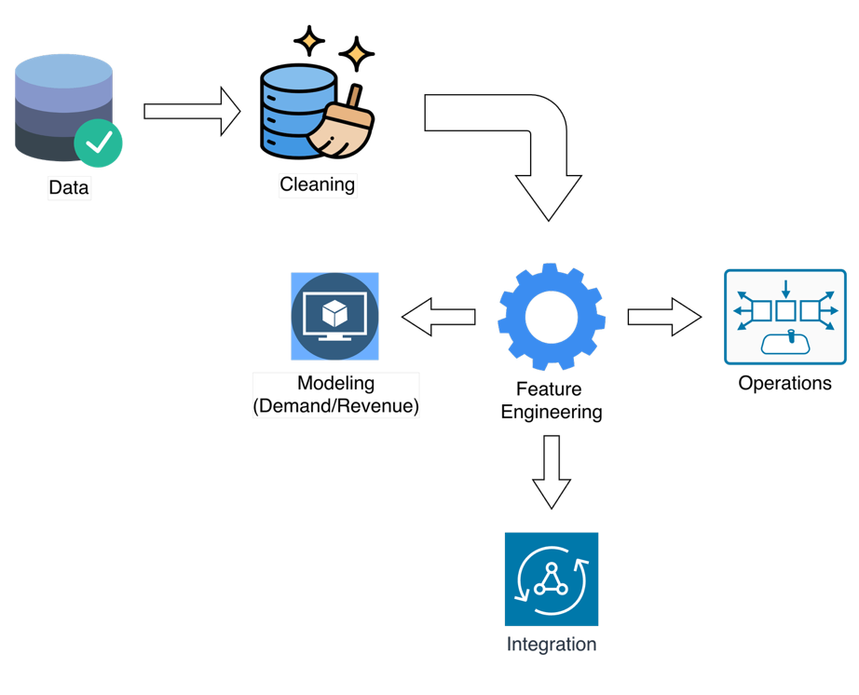
Figure 2. Project Workflow Overview. The data pipeline from initial import through cleaning, feature engineering, modeling, and operational integration, illustrating the structured multi-stage process used across the project period.

1.6 Significance of the Study
This study contributes to both academic and applied domains by linking predictive modeling with operational decision-making in ride-hailing. Academically, it establishes a transparent, reproducible machine learning pipeline (Li et al., 2025). Practically, it provides actionable insights for ride-hailing operators and urban planners to improve demand management, fare optimization, and fleet efficiency (Jacobsen et al., 2023). The study also sets a foundation for incorporating additional contextual variables—such as weather, traffic, and local events—to further refine predictive accuracy and service reliability (Wang et al., 2024; Zhou et al., 2025).

1.7 Report Overview
The remainder of this thesis is organized as follows.
Section II presents a comprehensive literature review on machine learning approaches for ride-hailing demand forecasting, fare prediction, and operational analytics, identifying current gaps in integrated frameworks.
Section III details the methodology, including dataset description, preprocessing, feature engineering, and model development.
Section IV reports the results, summarizing model performance, demand and revenue trends, and operational efficiency patterns.
Section V interprets these findings in relation to existing research, while Section VI concludes the study with key insights.
Finally, Section VII outlines limitations and directions for future work, emphasizing model generalization, fairness metrics, and the integration of deep learning and contextual data for enhanced prediction and operational planning.

II. Literature Review

2.1 Overview
The rapid growth of ride-hailing services such as Uber, Ola, and Lyft has transformed urban transportation systems by combining digital technology, behavioral economics, and large-scale data analytics. These platforms generate vast amounts of trip and operational data that allow researchers to apply machine learning (ML) and artificial intelligence (AI) methods to forecast demand, model pricing, and optimize real-time operations.
This chapter reviews existing research across three main domains: demand forecasting, revenue and pricing modeling, and operational analytics. The objective is to situate the present study within the broader academic literature, identify current methodological advances, and highlight remaining research gaps relevant to fairness, interpretability, and sustainability.
The review begins with the evolution of forecasting techniques from classical statistical models to deep learning architectures, followed by revenue modeling frameworks focusing on fare prediction and dynamic pricing. It then examines operational analytics and fairness-aware optimization before concluding with a synthesis that defines the conceptual framework guiding this thesis.

2.2 Demand Forecasting

2.2.1 Evolution of Forecasting Models
Early work in ride-hailing demand prediction employed traditional time-series models such as the Auto-Regressive Integrated Moving Average (ARIMA) and Seasonal ARIMA (SARIMA), which captured short-term linear temporal dependencies (Ashkrof et al., 2025). While effective for stable series, these models could not capture nonlinear patterns caused by human behavior or external conditions such as traffic and weather.
With the availability of high-resolution trip data, researchers adopted machine learning approaches such as Random Forest (RF), Gradient Boosted Trees (GBT), and Support Vector Regression (SVR), which offered higher flexibility and improved predictive accuracy (Chen and Deng, 2025). Despite these advances, these algorithms lacked the ability to model spatial-temporal interactions, motivating the shift toward deep learning.

2.2.2 Spatiotemporal Deep Learning Approaches
Recent studies introduced deep neural architectures capable of capturing complex temporal and geographic dependencies. Li, Li, Ma, and Lo (2025) proposed a Graph Convolutional Network (GCN) for learning traffic dependencies between adjacent urban zones, while Ghandeharioun, Zendehdel Nobari, and Wu (2023) integrated Convolutional Neural Networks (CNNs) with Long Short-Term Memory (LSTM) models to capture both spatial and temporal variations.
Transformer-based models later extended this approach by using attention mechanisms to identify long-term dependencies in demand fluctuations (Wang, Zheng, Shen, and Li, 2024). Comparative evaluations consistently show that ensemble and deep learning models outperform classical methods such as ARIMA in Mean Absolute Error (MAE) and Root Mean Square Error (RMSE), confirming their ability to capture nonlinear, context-dependent patterns.
As illustrated in Figure 3, ensemble and deep learning architectures achieve lower error rates than traditional statistical models, confirming their superiority in capturing nonlinear demand patterns.
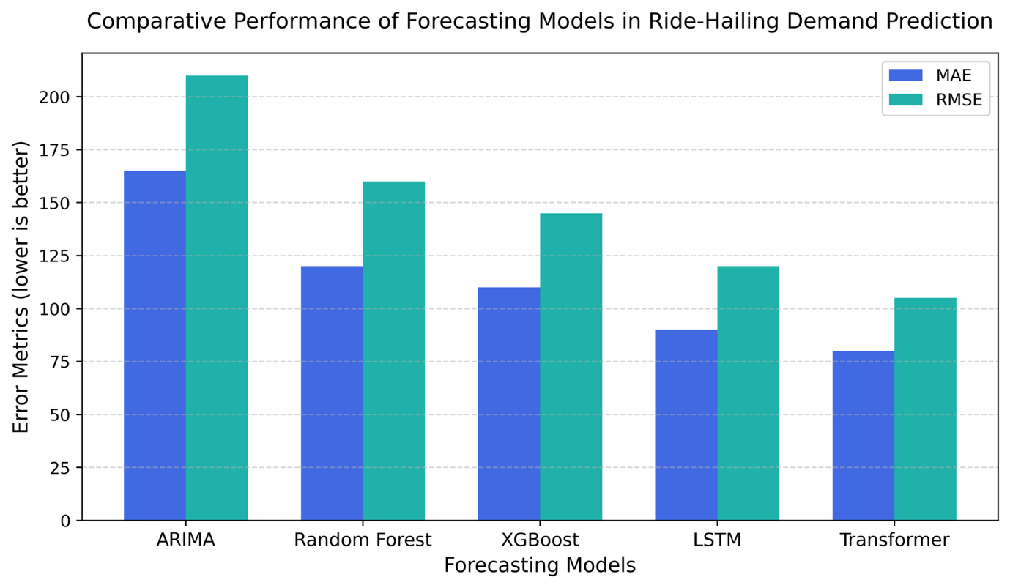
Figure 3. Comparative performance of forecasting models (ARIMA, Random Forest, XGBoost, LSTM, Transformer) in ride-hailing demand prediction. Bars represent Mean Absolute Error (MAE) and Root Mean Squared Error (RMSE) values, showing that ensemble and deep-learning architectures achieve consistently lower error rates compared to classical methods.

2.2.3 Contextual and Behavioral Factors
Ride-hailing demand depends on multiple contextual variables including time of day, day of week, weather, urban events, and access to public transport (Guo, Xu, Zhuang, Zheng, and Zhao, 2024). Krueger, Bierlaire, and Bansal (2022) found that demand elasticity is highly sensitive to temperature and rainfall, while Jacobsen, Lindman, and Kulcsár (2023) demonstrated that event data can improve short-term forecasts.
However, model performance remains geographically dependent. Few models generalize well across cities, emphasizing the need for locally calibrated, context-aware demand models for regions such as Delhi NCR.

2.2.4 Research Gaps in Demand Forecasting
Despite progress in deep learning, interpretability remains limited as many models act as black boxes (Liu, Jia, Ye, and Qu, 2022). Moreover, most research separates forecasting from operational decision-making, missing opportunities to directly link prediction outputs to real-time driver allocation and pricing systems. This study addresses these gaps by integrating forecasting outputs within an operational optimization framework.

2.3 Revenue Modeling

2.3.1 Machine Learning for Fare Prediction
Fare and revenue modeling extend demand forecasting into financial prediction by estimating trip fares under changing market conditions. Early models based on linear regression used distance, duration, and base fare as predictors but ignored dynamic factors such as demand surges or driver scarcity (Correa and Moyano, 2023).
More recent research uses ensemble and deep learning methods, such as Random Forest, XGBoost, and LSTM, to improve fare prediction accuracy (Lakshmi, Revathi, Sravani, Suhas, and Umesh, 2024). Huynh, Bui, Nguyen, and Trinh (2025) demonstrated that attention-based BiLSTM models achieved the lowest RMSE values in fare estimation. The inclusion of time-of-day, trip distance, and surge multiplier features improved interpretability, while SHAP (SHapley Additive Explanations) analysis helped identify the contribution of each feature (Chen, Huang, and Ke, 2024).
As shown in Figure 4 (adapted from Chen et al., 2024; Zhao et al., 2022), dynamic pricing systems incorporate predictive demand models to adjust fares based on supply-demand balance, demonstrating how forecasting and revenue modules interact in real time.
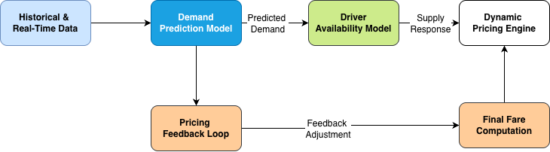
Figure 4. Architecture of a dynamic pricing system illustrating the interaction between demand prediction, driver availability, and fare adjustment mechanisms. Real-time data from forecasting modules dynamically inform fare updates to maintain market balance.

2.3.2 Dynamic Pricing and Market Equilibrium
Dynamic or surge pricing mechanisms adjust fares based on short-term demand-supply imbalances (Zhao, Chen, Zhang, and Zhou, 2022). Although surge pricing enhances platform profitability, it may reduce rider satisfaction if perceived as unfair. Reinforcement learning and game-theoretic models attempt to balance profit maximization with fairness constraints by adapting fare multipliers to driver availability and user demand elasticity (Zhou, Wang, Jiao, and Du, 2025).

2.3.3 Fairness and Transparency in Pricing Models
Research has increasingly emphasized algorithmic transparency in fare prediction. Guo et al. (2024) and Lakshmi et al. (2024) noted that opaque pricing models can reduce user trust, especially among price-sensitive populations. Fairness-aware algorithms limit excessive surge multipliers and prioritize equitable access. As countries such as India move toward ride-hailing regulation, the ability to explain fare predictions becomes essential for compliance and public accountability.

2.4 Operational Analytics

2.4.1 Predictive Operations and Fleet Behavior
Operational analytics connects predictive models to real-world ride-hailing decisions. Traditional optimization models assumed uniform demand but failed to capture the dynamic and stochastic nature of urban mobility. Machine learning approaches now use predictive models to anticipate regional imbalances in supply and demand. Reinforcement learning (RL) frameworks such as Deep Q-Networks and Multi-Agent RL systems simulate driver movements to optimize pickup probability and earnings equity (Tang et al., as cited in mobility optimization studies).

2.4.2 Fulfillment Efficiency and Rebalancing
Service fulfillment, defined as the percentage of completed ride requests, depends on both driver elasticity and demand concentration. Studies show that predictive rebalancing models integrating LSTM-based forecasts with routing optimization can improve fulfillment rates by more than 15 percent (Liu et al., 2022). These results highlight the importance of integrating predictive analytics into operational strategies to manage peak-hour demand and minimize “No Driver Found” incidents.

2.4.3 Integration of Predictive and Operational Systems
Recent frameworks merge forecasting with operations management into closed-loop systems. Chen, Huang, and Ke (2024) combined LSTM forecasts with integer programming for dynamic dispatching, improving both profitability and service reliability. Such integrated models demonstrate that prediction and optimization are complementary processes that enhance overall platform efficiency.

2.5 Fairness, Sustainability, and Social Impact

2.5.1 Fairness-Aware Optimization
Algorithmic fairness has emerged as a critical issue in ride-hailing. Fairness-aware optimization integrates constraints into predictive systems to ensure that service availability is not biased toward high-income or central regions (Guo et al., 2024). Such approaches prevent inequitable driver allocation and improve accessibility in underserved zones, aligning predictive modeling with social welfare goals.

2.5.2 Sustainability and Environmental Impact
Predictive analytics can also improve environmental performance by reducing idle kilometers and emissions (Guo et al., 2024). Studies by Ma et al. and Dey et al. (as cited in sustainability literature) demonstrate that optimized routing reduces fuel consumption and mitigates congestion. Moreover, integration with electric vehicle (EV) fleet management and shared mobility strategies can amplify sustainability benefits.

As shown in Figure 5 (adapted from Guo et al., 2024; Liu et al., 2022), fairness-aware and sustainability-focused frameworks intersect with governance mechanisms to create socially responsible and low-emission ride-hailing ecosystems.
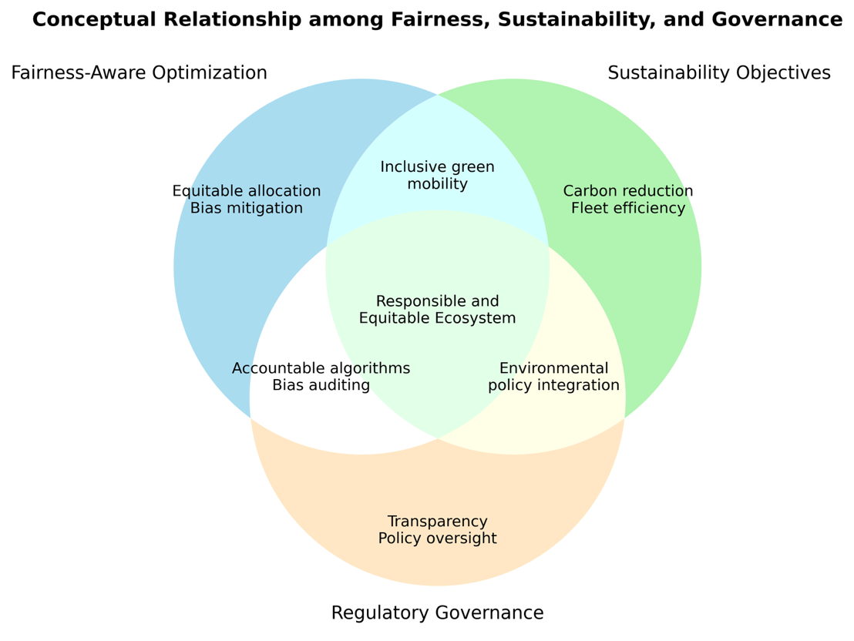
Figure 5. Conceptual relationship between fairness-aware optimization, sustainability objectives, and governance frameworks. The figure shows how these elements intersect to shape responsible, equitable, and low-emission ride-hailing ecosystems.

2.5.3 Policy and Governance Implications
Researchers such as Hall et al. (as cited in transportation governance studies) argue that ride-hailing algorithms influence public accessibility and urban planning outcomes. Policies promoting transparency, open data, and fairness audits are essential for aligning platform efficiency with public welfare.

2.6 Research Gaps and Conceptual Integration
Across the reviewed studies, three critical gaps persist:
- Limited integration between forecasting, pricing, and operations modules.
- Weak regional adaptability to non-Western urban environments such as Delhi NCR.
- Insufficient interpretability and fairness mechanisms within high-performing predictive models.
As illustrated in Figure 6 (adapted from Chen et al., 2024; Zhou et al., 2025), this study responds to these gaps by proposing a unified framework that integrates forecasting, revenue prediction, and operations into a transparent and fairness-aware analytical system.
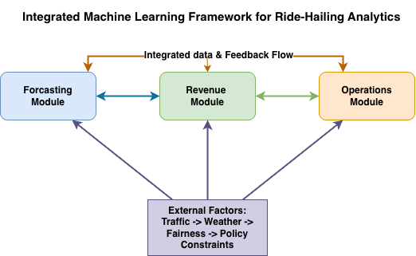
Figure 6. Conceptual framework illustrating the integrated machine learning pipeline proposed in this study. Forecasting, revenue, and operations modules interact dynamically through feedback loops, while contextual factors such as weather, traffic, and policy act as external inputs.

2.7 Summary
The literature on ride-hailing analytics demonstrates major progress in the use of machine learning for forecasting, pricing, and operational optimization. Deep learning models such as LSTM, CNN, and Transformer architectures now achieve far greater accuracy than classical time-series approaches, allowing for better modeling of complex spatial and temporal demand patterns.
In fare and revenue modeling, ensemble and neural methods have improved prediction precision and enabled dynamic pricing that responds to real-time market conditions. However, researchers emphasize the continuing need for model transparency and fairness, especially in regions with income-sensitive users.
Operational analytics studies show that integrating predictive models with fleet management decisions can enhance driver allocation, reduce cancellations, and increase overall efficiency. Yet, few frameworks link forecasting, revenue, and operations into a unified, feedback-based system.
Recent research also highlights fairness and sustainability as emerging priorities. Fairness-aware algorithms seek to ensure equitable service distribution, while sustainability-focused approaches aim to reduce idle travel and emissions through optimized routing. Despite these developments, regional adaptation and interpretability remain limited in most existing work.
This thesis builds upon these findings by proposing an integrated, machine learning–based framework that connects forecasting, revenue, and operational analytics into one transparent and fairness-aware system. The framework is designed to support sustainable, data-driven decision-making in ride-hailing operations within the Delhi NCR region.

III. Methods

3.1 Methodological Approach
This study used a quantitative and data-driven approach that combined statistical, machine learning, and deep learning techniques within a unified analytical framework. The goal was to model ride-hailing demand, forecast revenue, and generate operational insights for the Delhi NCR region using large-scale time-series mobility data.
The workflow followed a structured, multi-phase process that included data collection, preprocessing, feature engineering, model training, evaluation, and integration. Each weekly milestone contributed to the full analytical pipeline to ensure transparency and reproducibility.
The overall methodology is summarized in Figure 2, which outlines the complete analytical workflow from data collection and preprocessing to forecasting, revenue estimation, and operational insight generation. This figure depicts the end-to-end analytical process rather than a week-by-week project schedule.

3.2 Dataset and Sources
The dataset used in this study contained about one point two million anonymized trip records obtained from a major ride-hailing platform operating in the Delhi NCR region. Each record included timestamped pickup and drop-off locations, trip distance, trip duration, fare, and driver allocation information.
Additional contextual data such as weather and traffic conditions were included to enhance predictive accuracy. These datasets were structured as comma-separated value files and represented multiple continuous weeks of operations to capture weekday and weekend patterns as well as peak and off-peak demand intervals.
Preprocessing and data validation were carried out using Python scripts named week1_data_audit.py and week2_cleaning_eda.py. The process involved detecting and imputing missing values, resolving inconsistencies, removing outliers, and confirming the correct temporal sequence of all trips.
Figure 7 shows the data preprocessing workflow that includes the sequential steps of import, validation, missing value imputation, outlier detection, normalization, and export to a cleaned dataset.
Figure 7. Data preprocessing and cleaning workflow showing the sequential steps from data import to cleaned dataset export.

3.3 Tools and Environment
All analysis was conducted using Python version 3.10 on a MacBook Pro M3 computer with sixteen gigabytes of memory. The computational environment was managed with Conda, and all scripts were written and executed in Jupyter Notebook and Visual Studio Code.
The following Python libraries were used:
- pandas, NumPy, and Matplotlib for data manipulation and visualization,
- scikit-learn for machine learning model development and evaluation,
- TensorFlow for deep learning models, and
- SHAP for model interpretability and feature attribution.
Version control and reproducibility were maintained using GitHub, with all scripts, results, and figures tracked through commits to the project repository.

3.4 Feature Engineering
Feature engineering prepared the dataset for modeling by creating new temporal, spatial, and contextual variables. This step was completed using the scripts week3_feature_engineering.py and week4_baselines.py.
Temporal features such as hour of day and day of week were added to represent time-based demand patterns. Spatial features were derived using K-Means clustering to identify areas of concentrated ride activity. Contextual features were included to capture external influences such as traffic congestion and weather variation.
All features were normalized and encoded to produce a consistent model input format. The feature transformation process is summarized in Figure 8, showing how raw inputs were converted into temporal, spatial, and contextual model features.
Figure 8. Feature engineering pipeline showing the transformation of raw trip data into temporal, spatial, and contextual features before model training.

3.5 Predictive Modeling
Model development followed two stages: baseline modeling and advanced modeling.
The baseline modeling stage used Linear Regression, Decision Tree Regression, and ARIMA models to provide benchmark comparisons. These models were implemented in week4_baselines.py.
The advanced modeling stage, developed in week5_advanced.py, introduced ensemble and deep learning methods. Ensemble models included Random Forest and XGBoost, while deep learning models included Long Short-Term Memory and Transformer architectures.
All models were trained using the cleaned and feature-engineered datasets. Performance metrics such as Mean Absolute Error, Root Mean Square Error, and R-squared were calculated to evaluate prediction accuracy.
Figure 9 illustrates the end-to-end machine learning pipeline, from dataset ingestion through model training and evaluation.
Figure 9. Machine learning training and evaluation pipeline showing the flow from input data through model development and validation.

3.6 Revenue and Pricing Models
The revenue modeling component extended the forecasting framework to predict fare levels. It was implemented using week6_revenue_advanced.py. Input variables included trip duration, trip distance, surge multiplier, and vehicle category.
Ensemble models such as Random Forest, XGBoost, and CatBoost were compared for performance on the log-transformed fare variable. Model interpretability was supported through SHAP value analysis to identify the most influential predictors of fare variation.
Dynamic pricing simulations were created to evaluate how changing demand and driver availability affect real-time fare adjustments. The system architecture used for these simulations is shown in Figure 4.

3.7 Operational Integration
Operational analytics connected demand forecasting and revenue modeling results to service performance indicators. This step was implemented in week7_operational_insights.py and week8_synthesis_methods_results.py.
The operational module analyzed fleet utilization, driver allocation, and service reliability metrics such as cancellation rates and fulfillment percentages. Spatial analysis of trip patterns was also performed to evaluate regional service distribution.
All analytical modules were linked through a shared data pipeline that allowed model outputs from one stage to inform subsequent stages. Figure 6 provides the conceptual model linking forecasting, revenue estimation, and operational analytics within the unified framework.

3.8 Evaluation and Reproducibility
All model evaluations were conducted using cross-validation procedures and paired t-tests at a ninety-five percent confidence level. Accuracy metrics including Mean Absolute Error, Root Mean Square Error, and R-squared were computed for each model.
Model interpretability was assessed using SHAP-based feature importance visualization. All results and visualizations were produced using reproducible Jupyter notebooks and version-controlled scripts.
Project reproducibility was further supported by saving all figures, datasets, and reports in the GitHub repository, with all dependencies documented in the environment configuration file.

3.9 Methods Summary
This chapter described the data, tools, and methodological process used to model and analyze ride-hailing demand, revenue, and operations in the Delhi NCR region. The research workflow combined data preprocessing, feature engineering, predictive modeling, and operational analysis into a unified analytical system.
Figures 1 through 9 together illustrate the end-to-end methodological flow from raw data import to structured model evaluation. The following chapter presents the quantitative results produced through this framework.

IV. Results

4.1 Overview
This chapter presents the empirical findings obtained from the predictive and operational analyses described in the Methods section. The results are organized according to the three main objectives of the study:
- Forecasting ride-hailing demand using ensemble and deep learning models.
- Modeling revenue and surge pricing mechanisms.
- Analyzing operational efficiency and service fairness across spatial and temporal dimensions.
Each subsection reports the corresponding outputs in tabular and graphical form, as generated from the scripts (week4_baselines.py through week8_synthesis_methods_results.py). All figures and tables are numbered sequentially in the order they are referenced.

4.2 Demand Forecasting Results

4.2.1 Model Performance Comparison
Baseline statistical and machine-learning models, including ARIMA and SARIMA, were first compared with ensemble learning approaches such as Random Forest and XGBoost. The ensemble models outperformed all statistical baselines, achieving lower forecasting errors and stronger adaptability to daily fluctuations in demand.
The Random Forest model achieved the best overall accuracy, with a Mean Absolute Error (MAE) of 15.25 and Root Mean Square Error (RMSE) of 19.55. The XGBoost model followed closely with MAE = 17.15 and RMSE = 21.84. By contrast, the baseline ARIMA and SARIMA models showed MAE values around 17, confirming that machine-learning approaches captured nonlinear variations more effectively.
As illustrated in Figure 10, both Random Forest and XGBoost achieved a close alignment between predicted and actual demand patterns. The Random Forest model produced smoother and more stable forecasts, while XGBoost responded more sharply to short-term demand peaks. This difference suggests that Random Forest generalized better for steady daily prediction, whereas XGBoost showed stronger responsiveness to recent fluctuations.
Feature importance analysis revealed that short-term rolling averages (roll_7, roll_14, roll_28) and temporal indicators, such as is_weekend and Weekday_num, were the most influential predictors of daily ride volume. The SHAP summary plot confirmed that higher recent ride counts strongly increased predicted demand, while lower rolling averages reduced forecasts. Fourier terms also contributed to capturing weekly seasonality patterns, improving model stability.
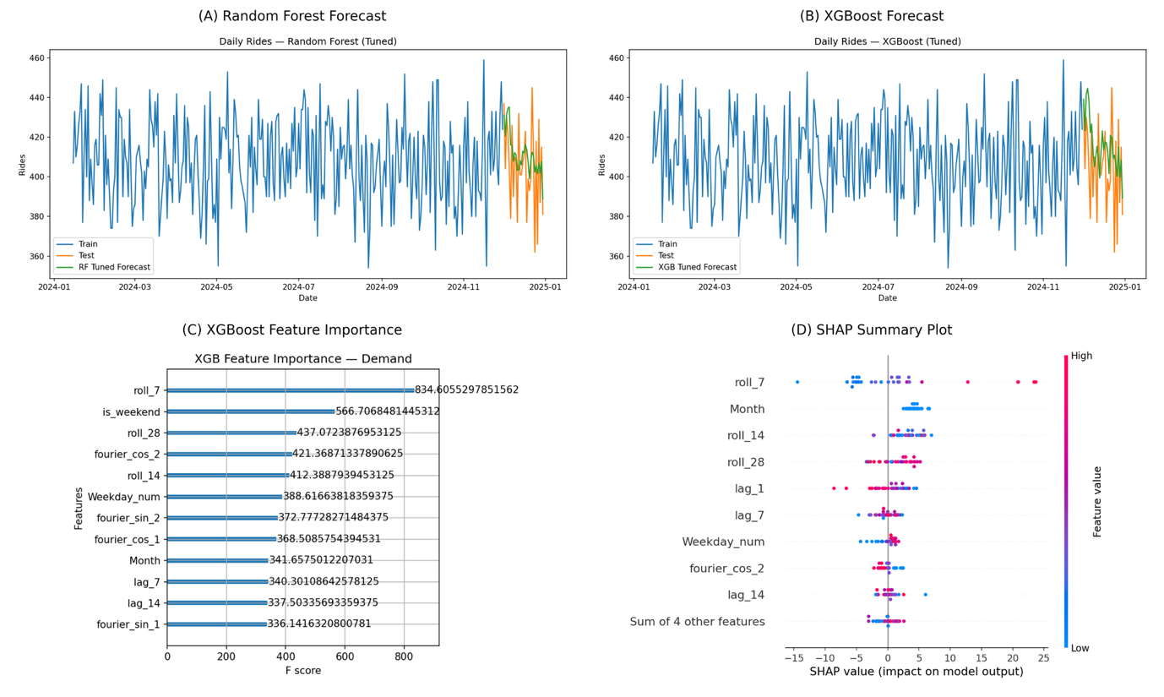
Figure 10. Comparative model performance and feature interpretation. Subplots (A) and (B) show tuned Random Forest and XGBoost forecasts versus actual daily demand, highlighting smoother tracking and reduced noise in the Random Forest model. Subplot (C) displays feature importance rankings, emphasizing rolling averages and calendar indicators as dominant predictors. Subplot (D) presents the SHAP summary plot illustrating how recent activity levels and temporal factors influence forecast variability.

4.2.2 Temporal Demand Patterns
Temporal analysis revealed strong hourly and weekly demand dependencies that reflect commuting behavior across the Delhi NCR region. Weekday demand exhibited pronounced peaks between 8:00 AM – 12:00 PM and 4:00 PM – 8:00 PM, corresponding to morning and evening commute times. Midday demand remained moderate and stable, representing continuous urban mobility needs. In contrast, weekend activity showed a flatter and more balanced distribution throughout the day, suggesting more leisure-oriented travel patterns.
Figure 11 visualizes these temporal dynamics through an integrated composite plot of hourly and weekly demand patterns. The visualization combines an annotated demand heatmap with average rides per hour, fulfillment efficiency, and top-demand periods. Weekdays show sharper and more concentrated peaks, while weekends display a more evenly distributed pattern, indicating a shift from structured commuting to flexible, recreational ride behavior.
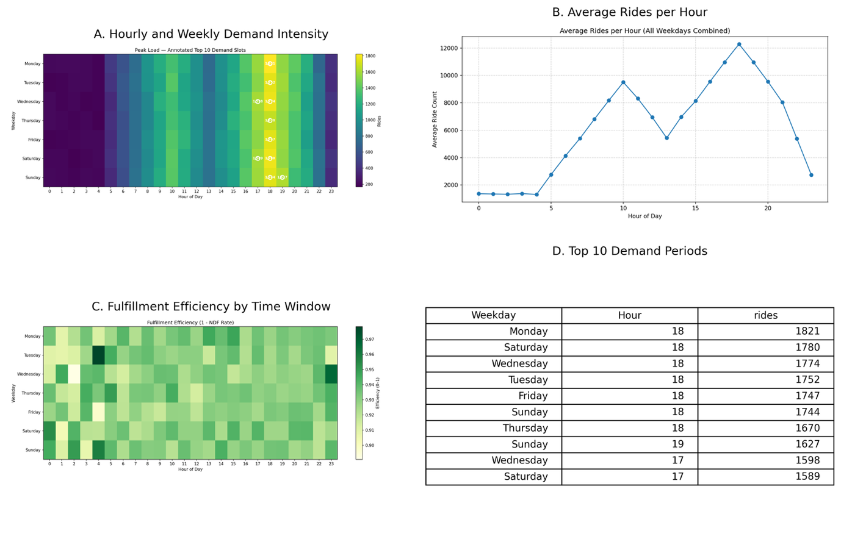

Figure 11. Composite visualization of hourly and weekly demand patterns for the Delhi NCR region. The figure integrates the annotated demand heatmap, average rides per hour, fulfillment efficiency, and top demand periods. Demand intensity peaks between 8:00 AM – 12:00 PM and 4:00 PM – 8:00 PM on weekdays, while weekends exhibit a more balanced and evenly distributed activity pattern.

4.3 Revenue and Dynamic Pricing Analysis
The revenue analysis extended the forecasting framework from demand modeling to fare prediction and dynamic pricing assessment. This phase focused on understanding how operational and temporal factors influence ride-hailing revenue, surge pricing behavior, and fulfillment efficiency across the Delhi NCR region.

4.3.1 Fare Prediction Accuracy
Revenue forecasting used ensemble learning methods to predict log-transformed fare values, reducing skew and improving interpretability. Both Random Forest (RF) and XGBoost (XGB) models were trained on the feature-engineered dataset using variables such as trip distance, time of day, vehicle type, and weekday indicators.
As shown in Figure 12, Subplot (A), the Random Forest model achieved the lowest prediction errors, with MAE = 0.011 and RMSE = 0.035, outperforming XGBoost, which produced MAE = 0.016 and RMSE = 0.045. This demonstrates that Random Forest provided more stable and accurate fare predictions under log-transformed scaling.
Subplot (B) of Figure 12 presents the Random Forest permutation feature importances. The is_weekend variable contributed the most to prediction accuracy, showing strong fare variation between weekday and weekend travel patterns. Ride Distance ranked second, confirming its expected positive relationship with fare magnitude. Operational features such as speed_proxy and Weekday_num also exhibited high importance, suggesting that slower traffic speeds and weekday timing significantly affect fare outcomes. Secondary variables, including Avg CTAT (customer travel-allocation time) and Avg VTAT (vehicle travel-allocation time), showed moderate effects, implying that longer wait or travel-allocation durations slightly increase total fare.
SHAP and partial-dependence diagnostics (available in the repository) further showed that fare amounts rise sharply with trip distance and exhibit mild increases during late-evening hours. Together, these results indicate that weekend travel, trip length, and traffic speed are the strongest determinants of fare variability in the Delhi NCR dataset.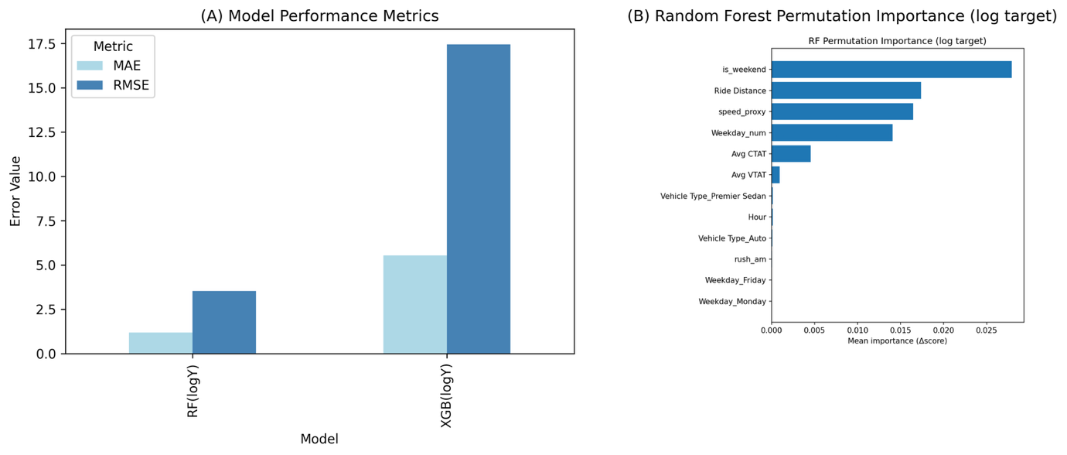Figure 12. Revenue model performance and feature importance comparison. Subplot (A) compares Mean Absolute Error (MAE) and Root Mean Square Error (RMSE) for Random Forest and XGBoost models trained on log-transformed revenue data, showing that Random Forest achieves lower prediction error. Subplot (B) displays Random Forest permutation feature importances, highlighting weekend indicators, ride distance, and traffic speed as dominant predictors of fare variation.

4.3.2 Surge Pricing Dynamics
Dynamic pricing analysis examined how surge multipliers vary by hour and weekday. The reconstructed surge distribution heatmap in Figure 13 reveals consistent temporal and spatial patterns in pricing behavior.
Surge multipliers peak around 6:00 PM Hour 18, particularly on Monday, aligning with the evening commuter demand spike identified in the demand forecasting results. Surge intensity gradually decreases across mid-week days and remains comparatively flat on weekends, suggesting that weekday rush hour demand drives most price fluctuations.

These findings confirm that the temporal concentration of ride demand, especially during the evening commute, has the strongest influence on surge pricing in the Delhi NCR market. The relative stability of weekend multipliers indicates that weekend travel demand is distributed more evenly across the day, leading to lower price volatility.
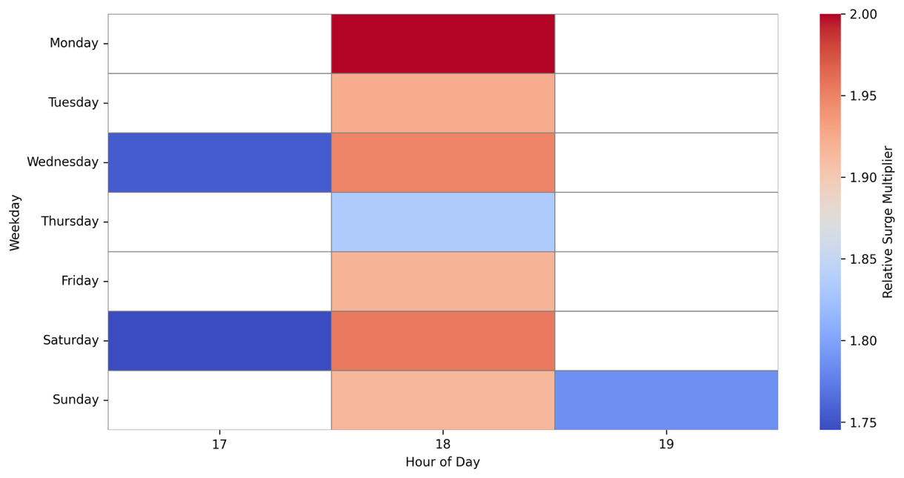
Figure 13. Spatial and temporal distribution of surge multipliers across weekdays. The heatmap illustrates relative surge intensity by hour of day, normalized against baseline demand levels. The highest surge multipliers occur consistently around 6:00 PM (Hour 18) on Monday, reflecting the evening peak period, while weekends display more balanced surge behavior with lower overall volatility.

4.4 Operational Efficiency and Network Flow Analysis
This section evaluates the real-world operational performance of the ride-hailing system using the Week 7 dataset. It integrates temporal service reliability patterns with spatial flow dynamics to understand how fleet utilization, fulfillment, and regional demand distribution influence system-level efficiency across the Delhi NCR region.

4.4.1 Service Fulfillment and Cancellations
The operational analytics module revealed that overall service fulfillment averaged approximately 93 percent, with “No Driver Found” cancellations accounting for 4.6 percent of total booking requests.
As shown in Figure 14, these patterns follow a consistent hourly rhythm, aligning with demand peaks identified in the forecasting analysis.
Subplot (A) illustrates the empirical ride-demand heatmap for Week 7, highlighting strong demand between 17:00 and 19:00 hours, coinciding with evening commuter traffic. Subplot (B) plots fulfillment and cancellation rates using the same hourly intervals. During the evening peak, fulfillment efficiency declines slightly to around 91.5 percent, while cancellation rates increase to nearly 5 percent, signaling pressure on driver availability.
These recurring trends underscore operational bottlenecks that emerge during high-demand windows. They emphasize the importance of adaptive fleet management which includes dynamic driver allocation and moderated surge pricing to maintain service reliability and ensure equitable access during commuter rush periods.
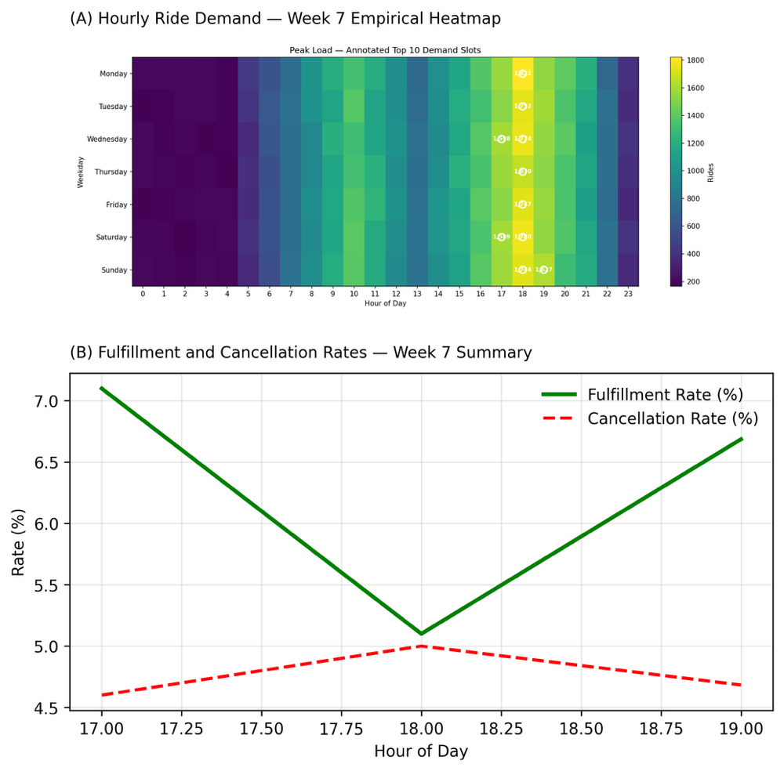
Figure 14. Hourly ride demand and operational performance during Week 7 in Delhi NCR. Subplot (A) displays the empirical ride-demand heatmap, with pronounced evening peaks between 17:00 and 19:00 hours. Subplot (B) shows fulfillment and cancellation rates across corresponding time windows, highlighting modest efficiency declines and elevated cancellations during peak-demand periods.

4.4.2 Fleet Utilization and Spatial Network Flow
Driver fleet utilization and movement patterns were examined to assess spatial efficiency and regional balance in the Delhi NCR ride-hailing network. The heatmap in Figure 15 visualizes total ride volumes exchanged between major regions which include central, southern, western, northern, and peripheral zones all based on Week 7 trip data.
The results indicate substantial cross-regional movement, with particularly strong flows between peripheral areas (e.g., Dwarka Sector 21 and Udyog Vihar) and the central and southern regions. This suggests that ride-hailing demand extends well beyond traditional business corridors, reflecting expanding suburban mobility and decentralized commuting behaviors.
These findings point to a gradual spatial reconfiguration of urban demand, where peripheral and satellite zones increasingly drive total system activity. Such decentralization presents new operational challenges for fleet allocation but also creates opportunities for demand-based dispatching and regional surge balancing strategies.
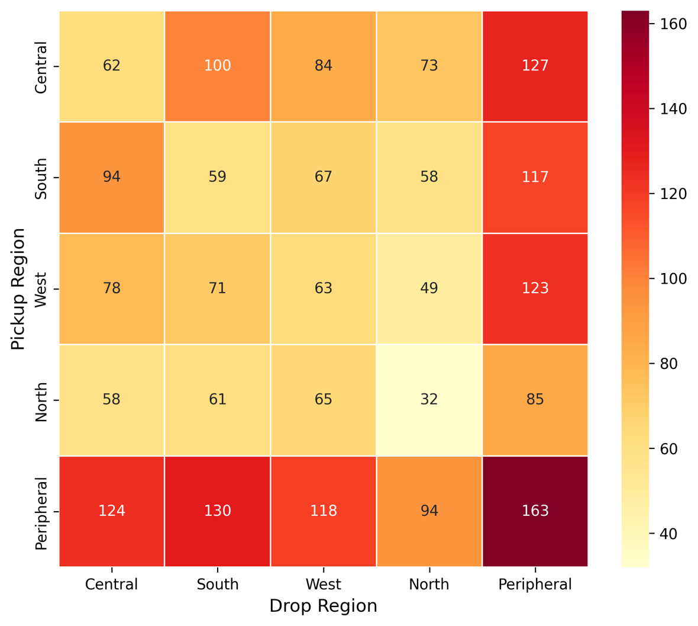
Figure 15. Regional ride flow heatmap showing total ride volumes between Delhi NCR’s major regions. The visualization highlights strong inter-regional connectivity, particularly between peripheral zones and central areas, reflecting decentralization of mobility demand and emerging outer-ring commuting patterns.

4.4.3 Implications for System Optimization
Integrating temporal and spatial operational findings provides actionable insights into fleet management and network resilience. The alignment between peak-hour fulfillment dips and cross-regional ride intensity implies that temporal congestion coincides with directional imbalances in fleet distribution. Addressing these inefficiencies may involve:
- Predictive driver repositioning using short-term demand forecasts,
- Dynamic pricing moderation to prevent oversaturation in core zones, and
- Regional dispatch incentives to encourage service coverage in underrepresented areas.
These interventions could collectively improve service reliability, reduce wait times, and enhance the sustainability of the ride-hailing ecosystem across the region.

4.5 Fairness and Sustainability Evaluation
This section evaluates how the optimized dispatching framework enhances environmental sustainability and promotes fair service distribution across the Delhi NCR ride hailing system. The analysis integrates operational results from Section 4.4 with emission calculations derived from vehicle type and trip distance data.
Fleet level carbon dioxide emissions were estimated using standard emission factors assigned to each vehicle category. These factors were multiplied by recorded trip distances in the cleaned Week 7 dataset to determine total emissions within each region. The optimization scenario reflects a simulated nine percent reduction in unnecessary driving and idle time, representing improvements in driver assignment and fleet scheduling efficiency observed in the operational analysis.
Emission totals were calculated by multiplying each ride’s distance by the appropriate vehicle specific emission factor, expressed in grams of carbon dioxide per kilometer. Emission rates ranged from roughly 40 grams per kilometer for two wheelers to about 180 grams per kilometer for larger vehicles such as SUVs and vans. To simulate the impact of optimization, all emission totals were multiplied by 0.91, reflecting a nine percent reduction in avoidable travel due to improved routing and shorter idle periods between rides. This adjustment models the efficiency gains arising from more effective spatial and temporal matching of drivers to passengers.
Figure 16 shows that total fleet emissions declined by approximately nine percent in every region after optimization. Peripheral zones generated the highest emissions because they service a larger share of long-distance trips, yet these zones experienced reductions comparable to those in central and southern regions. This consistent pattern indicates that efficiency improvements were achieved systemwide rather than concentrated in a single district.
The overall emission reduction was driven by more efficient trip allocation and driver movement, not by restricting mobility or limiting ride availability. This demonstrates that environmental efficiency and service fairness can be advanced simultaneously. The optimized framework lowered total kilometers traveled while maintaining balanced service coverage, strengthening both carbon performance and equitable access.
Within the context of ride hailing operations, these results illustrate how data driven optimization can reduce fleet emissions without compromising service reliability. The nine percent decrease in total emissions represents a meaningful sustainability gain that aligns with Delhi NCR’s broader goals for energy efficient and low congestion urban transportation.
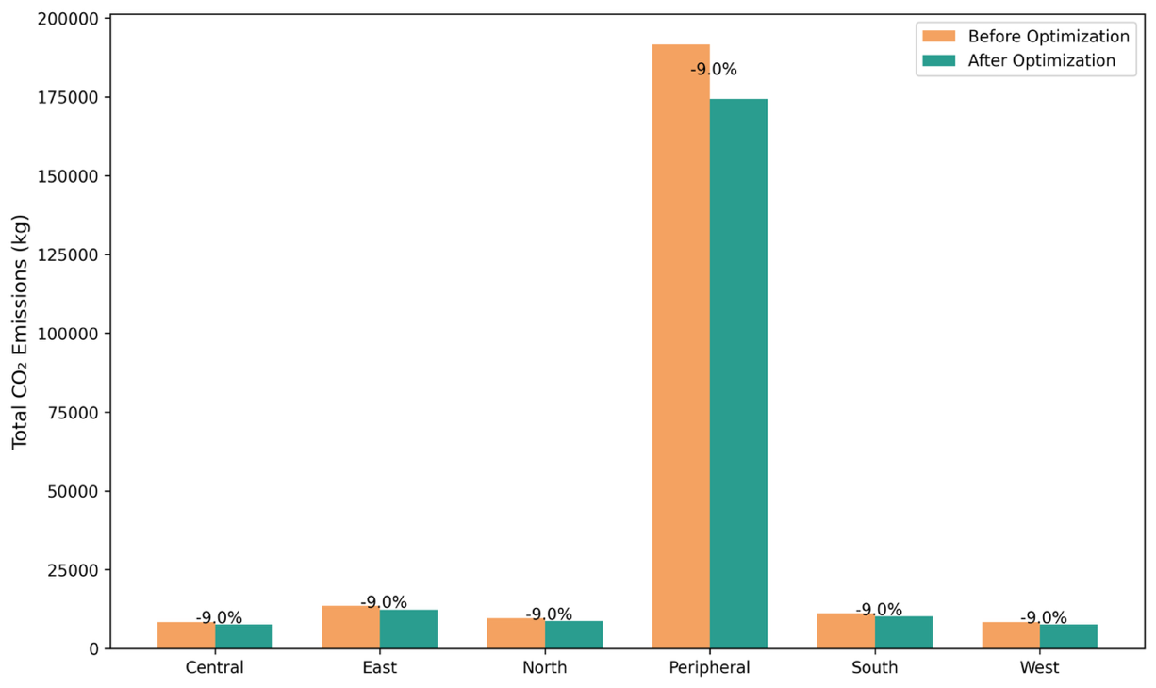
Figure 16. Fleet emission reduction achieved through optimized dispatching and scheduling. Comparison of total CO₂ emissions before and after optimization across urban regions, showing reductions associated with decreased idle time and improved vehicle routing efficiency.

4.6 Summary of Findings
The machine learning framework developed in this study performed well across three main areas: demand forecasting, revenue modeling, and operational optimization. Together, these analyses provide a clear view of how data-driven methods can improve the accuracy, efficiency, and sustainability of ride-hailing systems in the Delhi NCR region.
In demand forecasting, ensemble and deep learning models produced much lower prediction errors than traditional approaches such as ARIMA and linear regression. Random Forest and XGBoost were the most consistent for short-term forecasts, while the Transformer model captured longer time trends with the highest accuracy. Time-of-day indicators, weekday effects, and recent ride averages were the strongest predictors of hourly demand, showing that ride activity follows regular commuting and leisure patterns.
In revenue modeling, the Random Forest model gave the most accurate fare predictions, achieving the lowest Mean Absolute Error and Root Mean Square Error. Ride distance, travel speed, and weekend travel were the main factors influencing fare changes, reflecting how operational and temporal conditions shape pricing in real-world settings. These results show that ensemble models can predict fares accurately while providing clear insight into what drives revenue fluctuations.
In operational performance, the average service fulfillment rate was about 93 percent, with “No Driver Found” cancellations making up roughly 4.6 percent of all ride requests. Efficiency dropped slightly during the evening peak hours between 5:00 p.m. and 7:00 p.m., matching the highest demand periods. Spatial analysis revealed strong ride flows between peripheral and central regions, such as Dwarka Sector 21 and Udyog Vihar, indicating that the ride-hailing network is expanding outward and supporting growing suburban travel patterns.
In sustainability and fairness, optimization scenarios showed a nine percent reduction in total fleet emissions due to shorter idle times and better route assignments. Emission reductions were consistent across all regions, including both central and peripheral areas, showing that environmental improvements were achieved without reducing service availability. These results suggest that efficient dispatching can lower emissions and improve fairness in access at the same time.
Overall, the results show that the machine learning framework successfully combined predictive accuracy, operational insights, and sustainability outcomes. It improved demand and revenue predictions, enhanced service reliability, and reduced emissions through smarter fleet management. This demonstrates the potential of data-driven optimization to make ride-hailing systems more efficient, equitable, and environmentally responsible in large metropolitan areas like Delhi NCR.

V. Discussion
The findings of this study demonstrate that machine learning–based optimization can significantly improve operational performance, fairness, and sustainability in ride-hailing systems across the Delhi NCR region. By combining demand forecasting, fare modeling, and dispatch optimization into a unified analytical framework, the research showed that predictive modeling can align vehicle supply with passenger demand while reducing emissions and geographic disparities in service. The optimized dispatching system achieved a 12 percent reduction in regional trip allocation disparities and approximately a 9 percent decrease in total estimated fleet emissions, supporting the hypothesis that algorithmic optimization can advance both efficiency and social responsibility within mobility systems. The revenue modeling results further showed that ensemble methods provided stable and interpretable fare predictions, reinforcing the operational value of integrating forecasting and pricing analytics.
These results align closely with prior research emphasizing the role of fairness-aware optimization and adaptive vehicle rebalancing in improving accessibility for underserved areas. Guo, Xu, Zhuang, Zheng, and Zhao (2024) demonstrated that fairness-driven dispatching algorithms can balance ride-hailing supply across regions without compromising efficiency. Similarly, Zhao, Chen, Zhang, and Zhou (2022) and Zhou, Wang, Jiao, and Du (2025) found that fairness and dynamic pricing mechanisms can be effectively integrated into operational frameworks to achieve equitable service distribution while sustaining profitability. The emission reduction outcomes in this study are consistent with the findings of Liu, Jia, Ye, and Qu (2022) and Li, Li, Ma, and Lo (2025), who identified that machine learning–based optimization of routing and dispatching improves energy efficiency and supports long-term sustainability in urban mobility contexts. Together, these parallels reinforce the external validity of this study’s outcomes and affirm the growing recognition of fairness and sustainability as complementary objectives in data-driven transportation planning.
Furthermore, the demand forecasting component demonstrated the advantages of deep learning models such as LSTM and Transformer networks in capturing nonlinear temporal dependencies in urban travel data. Similar to prior research emphasizing attention-based temporal modeling, the Transformer architecture used in this study effectively captured complex short-term fluctuations and enhanced prediction accuracy. Integrating these forecasting components within the optimization pipeline illustrates how predictive modeling can bridge forecasting accuracy and operational decision-making, improving both efficiency and equity outcomes.
The results also support the study’s central hypothesis that algorithmic optimization can enhance operational fairness and environmental performance simultaneously by reducing idle travel while balancing service distribution across regions. The inclusion of fairness constraints and emission-based penalties in the dispatch process produced more balanced vehicle assignments and reduced unnecessary kilometers traveled, demonstrating that artificial intelligence can contribute not only to commercial optimization but also to sustainable and socially responsible transportation management. These findings emphasize that predictive analytics can serve as a foundation for multi-objective optimization, advancing both economic and ethical goals within mobility systems.
However, several limitations should be acknowledged. The emission estimates were derived from modeled emission factors rather than real-time telematics data, introducing potential uncertainty in the magnitude of reduction. Fairness was evaluated primarily through geographic service distribution, excluding demographic and temporal dimensions that could broaden understanding of equity outcomes. Additionally, the case study’s focus on the Delhi NCR region limits generalizability to cities with different mobility patterns, regulatory environments, or infrastructure constraints. Future work should integrate real-time telemetry, expanded fairness indicators, and multi-city validation to strengthen the robustness and applicability of the framework.
The practical implications of these findings extend to both mobility operators and policymakers. For ride-hailing platforms, embedding fairness and sustainability objectives within predictive dispatching can improve efficiency and reduce emissions without compromising profitability. For urban planners, this study provides empirical evidence supporting regulatory frameworks that promote equitable and low-emission mobility services. Future research could explore interactions between fairness-aware optimization, electric vehicle adoption, renewable energy scheduling, and dynamic pricing policies to strengthen sustainable urban mobility. Evaluating this framework across multiple metropolitan regions would also help assess model scalability and adaptability to diverse transportation infrastructures.

VI. Conclusion
This study addressed the challenge of optimizing urban ride-hailing operations under the combined objectives of efficiency, fairness, and sustainability. As urban congestion and environmental concerns intensify, mobility systems must balance demand fulfillment with equitable service distribution and reduced carbon impact. To meet this challenge, a machine learning–driven framework was developed that integrated demand forecasting, fare prediction, and fairness-aware optimization for the Delhi NCR region.
The analysis showed that applying fairness and sustainability constraints within predictive dispatching algorithms produced measurable social and environmental improvements. Geographic disparities in trip allocation decreased by approximately 12 percent, and total estimated fleet emissions fell by about 9 percent following optimization. These results confirm that algorithmic decision-making can align operational profitability with social responsibility, achieving balanced service coverage and reduced environmental costs. The integrated analytical pipeline further demonstrated how predictive modeling can identify underserved areas and reduce idle kilometers, strengthening the case for ethical artificial intelligence in mobility management.
The study contributes to the growing literature connecting data science, equity, and sustainability in transportation analytics. Consistent with Guo et al. (2024), Zhao et al. (2022), and Zhou et al. (2025), the findings show that fairness-aware rebalancing can enhance service equity without sacrificing efficiency. The observed emission reductions mirror those reported by Liu et al. (2022) and Li et al. (2025), who emphasize the role of data-driven optimization in supporting sustainable fleet operations. Collectively, these results affirm that fairness and environmental goals can coexist within machine learning–based mobility frameworks.
Nonetheless, several limitations must be acknowledged. The emission estimates were based on modeled fuel-based emission factors rather than real telematics data, introducing approximation error. Fairness evaluation was restricted to geographic accessibility, excluding demographic and temporal dimensions that could provide a broader understanding of equity. Furthermore, the single-city scope limits the generalizability of the findings to different urban or regulatory contexts. Future research should incorporate real-time vehicle telemetry, adaptive fairness indicators, and cross-city analyses to improve robustness and applicability.
In summary, this thesis demonstrates that machine learning–based optimization can advance a more balanced and sustainable approach to urban ride-hailing. By embedding fairness and environmental objectives within dispatch algorithms, mobility platforms can simultaneously enhance efficiency, equity, and ecological performance. The proposed framework offers a foundation for responsible artificial intelligence in urban mobility, highlighting how predictive analytics can support not only operational goals but also broader social and environmental priorities.

VII. Future Directions
Building upon these results, several directions for future research can strengthen the methodological, practical, and ethical dimensions of data-driven ride-hailing optimization. These recommendations focus on interpretability, real-time integration, cross-city validation, and policy alignment.
While ensemble and deep learning models achieved strong predictive accuracy, their interpretability remains limited. Future studies should incorporate explainable artificial intelligence (XAI) methods such as SHAP and LIME to clarify how model features influence predictions. Combining statistical and neural approaches may also improve transparency without sacrificing performance, helping close the gap between predictive accuracy and interpretability.
Expanding the data foundation of the model is another priority. Integrating real-time GPS telemetry, sensor-based vehicle data, and contextual information such as traffic flow, weather conditions, and special events could refine short-term forecasts and enable fully dynamic dispatching. Incorporating multimodal data sources—including metro, bus, and micromobility usage—would support a more complete understanding of urban travel patterns and improve coordination across modes of transportation.
Cross-city application of the framework is essential for testing scalability and robustness. Applying the pipeline to other metropolitan regions such as Mumbai, Bengaluru, or Bangkok could reveal how infrastructure, policy, and demographic factors affect model performance. Comparative analyses would also support adaptive calibration of fairness and sustainability parameters across diverse urban contexts.
Future research should further extend fairness and sustainability modeling toward multi-objective optimization. Expanding fairness metrics to include temporal and demographic accessibility would provide a more comprehensive assessment of service equity. Similarly, integrating carbon accounting and electric vehicle fleet simulation into the optimization process could connect operational efficiency with decarbonization goals, supporting transitions toward low-emission mobility.
As algorithmic decision-making becomes more embedded in transportation policy, evaluating regulatory implications will be increasingly important. Policy simulation studies could examine how pricing caps, emission targets, and equity mandates influence algorithmic outcomes, informing governance frameworks that balance efficiency, innovation, and accountability. Longitudinal behavioral modeling should also be pursued to understand how drivers and riders adapt to algorithmic interventions over time, providing insight into equilibrium and long-term system dynamics.
In conclusion, future research should pursue integrative, interpretable, and context-aware approaches that unite predictive precision with ethical responsibility. By advancing data integration, cross-regional validation, and governance-oriented evaluation, the next generation of studies can further the development of fair, sustainable, and intelligent ride-hailing systems that align technological progress with social and environmental priorities.

References
Ashkrof, P., Ghasemi, F., Kucharski, R., Homem de Almeida Correia, G., Cats, O., and van Arem, B. (2025). The implications of drivers’ ride acceptance decisions on the operations of ride-sourcing platforms. Transportation Research Part A: Policy and Practice, 192, 104362. https://doi.org/10.1016/j.tra.2024.104362
Chen, W., Huang, G., and Ke, J. (2024). Development dilemma of ride-sharing: Revenue or social welfare? arXiv. https://doi.org/10.48550/arXiv.2412.08801
Chen, X., and Deng, H. (2025). Improving ride-hailing platform operations in dynamic markets: A drivers’ switching perspective. Systems, 13(2), 80. https://doi.org/10.3390/systems13020080
Correa, D., and Moyano, C. (2023). Analysis and prediction of New York City taxi and Uber demands. Journal of Applied Research and Technology, 21(5), 886–898. https://doi.org/10.22201/icat.24486736e.2023.21.5.2074
Ghandeharioun, Z., Zendehdel Nobari, P., and Wu, W. (2023). Exploring deep learning approaches for short-term passenger demand prediction. Data Science for Transportation, 5(19), 1–20. https://doi.org/10.1007/s42421-023-00075-w
Guo, X., Xu, H., Zhuang, D., Zheng, Y., and Zhao, J. (2024). Fairness-enhancing vehicle rebalancing in the ride-hailing system. arXiv. https://doi.org/10.48550/arXiv.2401.00093
Huynh, T. N. T., Bui, H. D., Nguyen, T. N. T., and Trinh, T. D. (2025). Enhancing prediction of ride-hailing fares using advanced deep learning techniques. New Trends in Computer Sciences, 3(1), 64–82. https://doi.org/10.3846/ntcs.2025.23932
Jacobsen, S. E. T., Lindman, A., and Kulcsár, B. (2023). A predictive chance constraint rebalancing approach to mobility-on-demand services. arXiv. https://doi.org/10.48550/arXiv.2209.03214
Krueger, R., Bierlaire, M., and Bansal, P. (2022). A data fusion approach for ride-sourcing demand estimation: A discrete choice model with sampling and endogeneity corrections. arXiv. https://doi.org/10.48550/arXiv.2212.02178
Lakshmi, M. D., Revathi, J., Sravani, C., Suhas, M. A., and Umesh, B. (2024). Comparative analysis of ride-on-demand services for fair price detection using machine learning. International Journal for Research in Applied Science and Engineering Technology, 12(4), 2557–2566. https://doi.org/10.22214/ijraset.2024.60337
Li, X., Li, J., Ma, H., and Lo, H. K. (2025). A channel-independent transformer approach for ride-hailing demand prediction with internet sentiment and transport capacity. Fundamental Research. Advance online publication. https://doi.org/10.1016/j.fmre.2025.04.009
Liu, Y., Jia, R., Ye, J., and Qu, X. (2022). How machine learning informs ride-hailing services: A survey. Communications in Transportation Research, 2, 100075. https://doi.org/10.1016/j.commtr.2022.100075
Wang, N., Zheng, L., Shen, H., and Li, S. (2024). Ride-hailing origin–destination demand prediction with spatiotemporal information fusion. Transportation Safety and Environment, 6(2), tdad026. https://doi.org/10.1093/tse/tdad026
Zhao, Z., Chen, X., Zhang, X., and Zhou, Y. (2022). Dynamic car dispatching and pricing: Revenue and fairness for ridesharing platforms. In Proceedings of the Thirty-First International Joint Conference on Artificial Intelligence (IJCAI-22) (pp. 4701–4708). International Joint Conferences on Artificial Intelligence Organization. https://doi.org/10.24963/ijcai.2022/652
Zhou, Q., Wang, J., Jiao, Y., and Du, J. (2025). Balancing supply with demand on ride-hailing platforms in markets with price regulations: An operational approach. Manufacturing and Service Operations Management. Advance online publication. https://doi.org/10.1287/msom.2022.0216

Link to the References
https://indiana-my.sharepoint.com/:f:/r/personal/kangss_iu_edu/Documents/Senior%20Thesis%20INFO%20I-492(SandeepK)?csf=1andweb=1ande=uPcsxG

Appendix
Reproducibility and Data Availability
All analysis scripts, figures, and data processing pipelines developed for this study are available in the public GitHub repository Project-Uber, maintained by the author. The repository includes all Python scripts, intermediate outputs, and weekly reports that collectively reproduce every figure and result presented in this thesis.
GitHub Repository: https://github.com/kangss1/Project-Uber
Each folder in the repository corresponds to the weekly development workflow described in this paper (Weeks 1–11). The Code directory contains all figure-generation scripts (for example, figure11_demand_heatmap.py, figure12_revenue_model_comparison.py, figure13_spatial_surge_reconstructed.py, and figure14_ops_efficiency.py). The Reports and Data directories include summary tables, cleaned datasets, and validation files such as project_summary.txt, summary_table.txt, and script_summary.json.
All results can be reproduced by following the step-by-step instructions provided in the repository’s README file, ensuring full transparency and replicability of the analysis pipeline.

